E-Learning Resource
Objective:
E-Learning resource is an online application to be built education based website/software , helping students to get all resources & study materials of every courses available. It uses “E-Book” facility. It is reliable & time efficient approach compared to all links of the website provided by any search engine while searching for course materials.
Users of the System:
- Admin
- Professors
- Users
Functional Requirements:
- To provide official & legal links of the website from which user(student ) can download resources & study materials of relevant course.
- Only accessible after registering to that specific website.
- Getting associated with professors of esteemed institutes & colleges.
- To provide interaction between professor & students.
- Not all links provided by GOOGLE are virus free or recommended to download. This would be a better approach.

Output/ Post Condition:
- Records Persisted in Success & Failure Collections
- Standalone application / Deployed in an app Container

Non-Functional Requirements:

Security | - App Platform –UserName/Password-Based Credentials  - Sensitive data has to be categorized and stored in a secure manner  - Secure connection for transmission of any data
Performance | - Peak Load Performance  - E-Learning Resource -< 3 Sec  - Admin application < 2 Sec  - Non Peak Load Performance
Availability | - 99.99 % Availability
Standard Features | - Scalability  - Maintainability  - Usability  - Availability  - Failover
Logging & Auditing | - The system should support logging(app/web/DB) & auditing at all levels
Monitoring | - Should be able to monitor via as-is enterprise monitoring tools
Cloud | - The Solution should be made Cloud-ready and should have a minimum impact when moving away to Cloud infrastructure
Browser Compatible | - IE 7+  - Mozilla Firefox Latest – 15  - Google Chrome Latest – 20  - Mobile Ready

Technology Stack
Front End | Angular 7+  Google Material Design  Bootstrap / Bulma
Server Side | Spring Boot  Spring Web (Rest Controller)  Spring Security  Spring AOP  Spring Hibernate
Core Platform | OpenJDK 11
Database | MySQL or H2

Platform Pre-requisites (Do’s and Don’ts):
- The angular app should run in port 8081. Do not run the angular app in the port: 4200.
- Spring boot app should run in port 8080.

Key points to remember:
- The id (for frontend) and attributes(backend) mentioned in the SRS should not be modified at any cost. Failing to do may fail test cases.
- Remember to check the screenshots provided with the SRS. Strictly adhere to id mapping and attribute mapping. Failing to do may fail test cases.
- Strictly adhere to the proper project scaffolding (Folder structure), coding conventions, method definitions and return types.
- Adhere strictly to the endpoints given below.

Application assumptions:
- The login page should be the first page rendered when the application loads.
- Manual routing should be restricted by using AuthGaurd by implementing the canActivate interface. For example, if the user enters as http://localhost:4200/signup or http://localhost:4200/home the page should not navigate to the corresponding page instead it should redirect to the login page.
- Unless logged into the system, the user cannot navigate to any other pages.
- Logging out must again redirect to the login page.
- To navigate to the admin side, you can store a user type as admin in the database with a username and password as admin.
- Use admin/admin as the username and password to navigate to the admin dashboard.

Validations:
- Basic email validation should be performed.
- Basic mobile validation should be performed.
Project Tasks:
API Endpoints:
USER
Action | URL | Method | Response
Login | /login | POST | true/false
Signup | /signup | POST | true/false
Get All Resource | /home | GET | Array of Resource
Update Resource | /home/{id} | PUT | Updated Success
Add Resourse | /home | POST | Added Successfully
Delete Resource | /home/{id} | DELETE | Resource Deleted
Start Chat | /chat/{id} | POST | Chat Started
Get Chat | /chat/{id} | GET | Array of Chat
Delete Chat | /chat/{id} | DELETE | Chat Deleted
ADMIN
Action | URL | Method | Response
Get All User | /admin | GET | Array of Users
Approve User | /admin/verify | POST | User Verified
Delete User | /admin/delete/{id} | DELETE | User deleted
Update Resource | /admin/resourse/{id} | PUT | Updated Success

Frontend:
Login:
Output Screenshot:
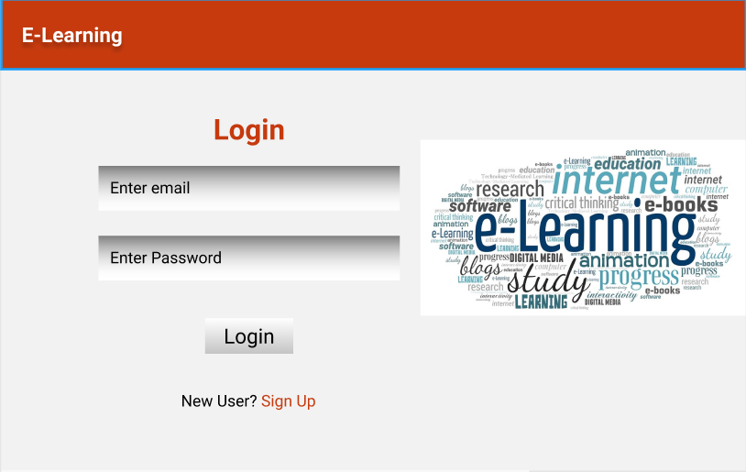

Signup:
Output Screenshot:
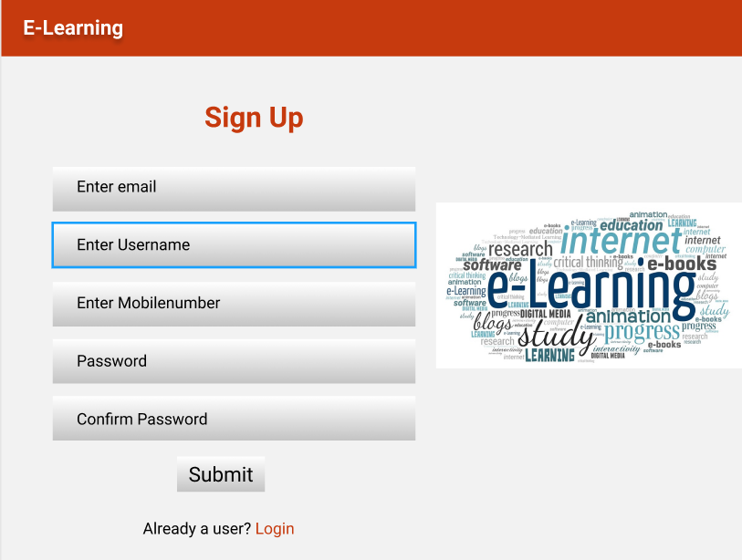
Home:
Output Screenshot: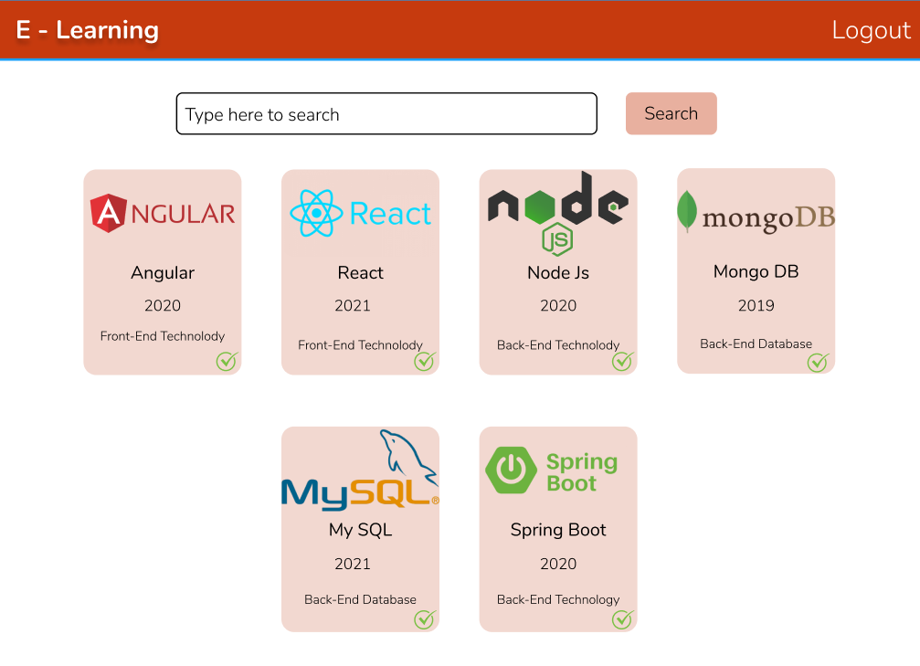
Resourse By Id:
Output Screenshot:
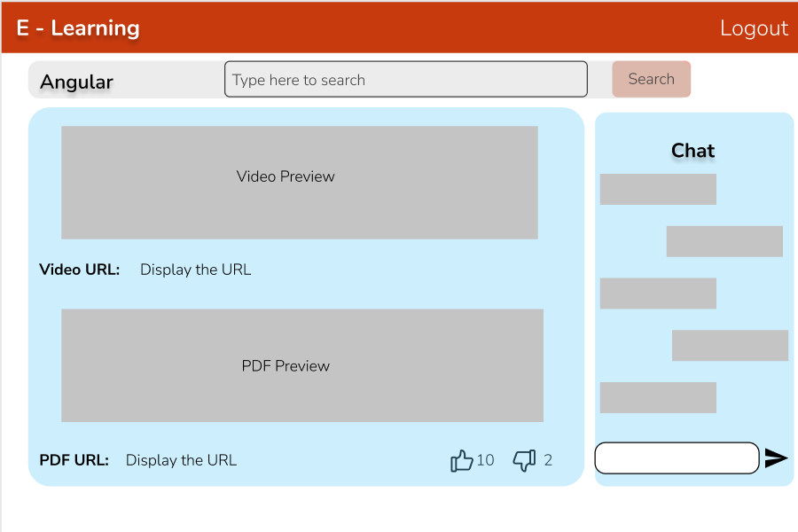
Admin:
Home
Output Screenshot:
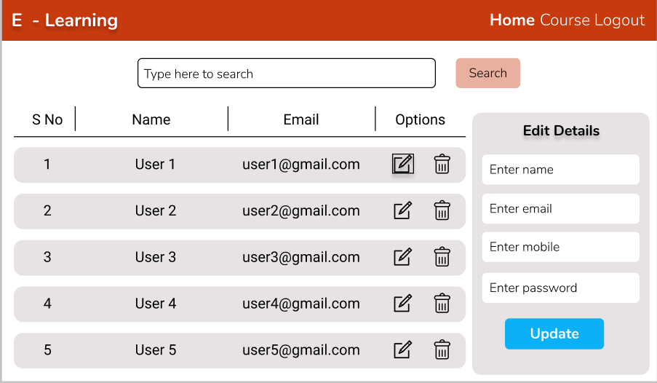

Resourse By Id:
Output Screenshot:
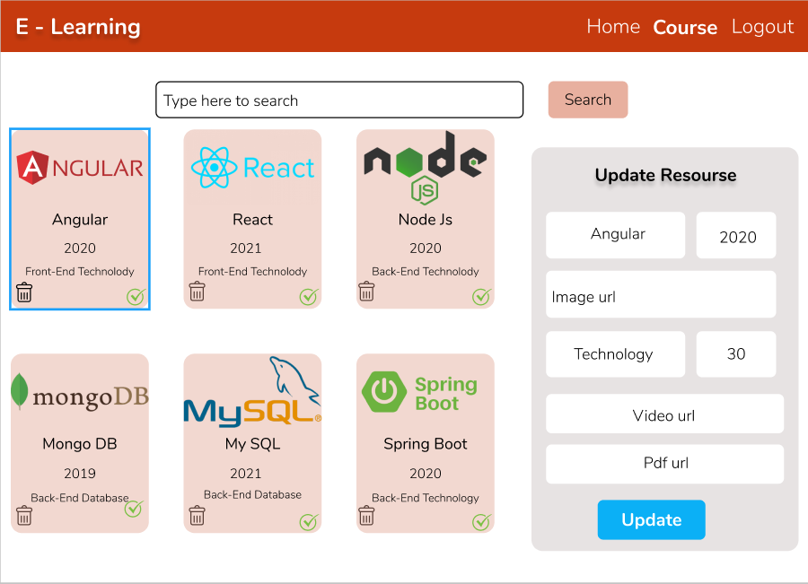

Backend:
Class and Method description:

Model Layer:

- UserModel: This class stores the user type (admin or the User) and all user information.
  - Attributes:
    - email: String
    - password: String
    - username: String
    - mobileNumber: String
    - qualification: String
    - active: Boolean
    - role: String
  - Methods: -
- LoginModel: This class contains the email and password of the user.
  - Attributes:
    - email: String
    - password: String
  - Methods: -
- ResourceModel: This class stores the all the resource provided by the verified User.
  - Attributes:
    - resourceId: String
    - resourceName: String
    - resourceLink: String
    - imageUrl: String
    - resourceCategory: String
    - createdOn: Date
    - createdBy: UserModel
    - verified: Boolean
    - active: Boolean
  - Methods: -
- chatModel: This class stores the communication between two user.
  - Attributes:
    - chatId: String
    - primaryUser: UserModel
    - secondaryUser: UserModel
    - chatHistory: List<String>
    - status: Boolean
    - lastSeen: Date
  - Methods: -
Controller Layer:
- SignupController: This class control the user signup
  - Attributes: -
  - Methods:
    - saveUser(UserModel user): This method helps to store users in the database and return true or false based on the database transaction.
- LoginController: This class controls the user login.
  - Attributes: -
  - Methods:
    - checkUser(LoginModel data): This method helps the user to sign up for the application and must return true or false
- ResourceController: This class controls the add/edit/update/view Resource.
  - Attributes: -
  - Methods:
    - List<ResourceModel> getResource(): This method helps the User to fetch all resource from the database.
    - ResourceModel resourceById(String id): This method helps to retrieve a Resourse from the database based on the resource id.
    - resourceEditSave(ResourceModel data): This method helps to edit a resource and save it to the database.
    - resourceSave(ResourceModel data): This method helps to add a new resource to the database.
    - resourceDelete (String id): This method helps to delete a resource from the database.
- ChatController: This class helps to store the communication between the students and Professors.
  - Attributes: -
  - Methods:
    - startChat(String id): This method helps the user to communicate with the professor.
    - List<ChatModel> showChat(String id): This method helps to view the chat based on chatId.
    - deleteChatItem(String id): This method helps to delete a chat from the database.

